Sample Problem: Strategic Interaction

Q1. Given the following payoff matrix in millions of dollars, what is the Nash equilibrium of the game?

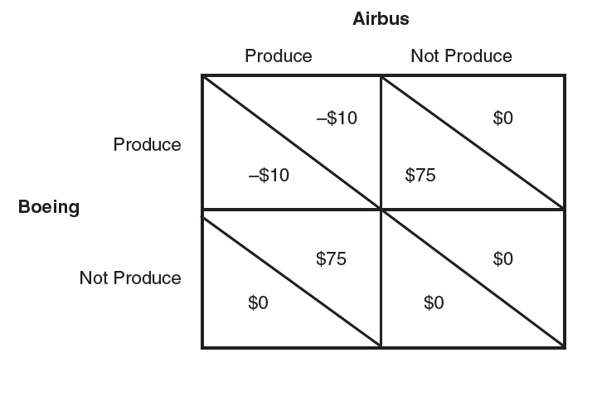

1. Suppose the governments of Europe seek to expand Airbus’ international market share by providing the European aircraft producer with a subsidy of $25 million for R&D. Redraw the payoff matrix and find the Nash equilibrium. Is the subsidy successful in increasing European welfare? Explain.
2. Suppose now Boeing has a comparative advantage over Airbus in producing planes such that the American producer earns a profit of $10 million if both firms produce and a profit of $100 if Airbus stays out of the market. Redraw the payoff matrix and find the Nash equilibrium. Examine the net welfare effect on Europe when the European producer receives a subsidy.

.